Magic Valley

Weather: Sunset 8:52

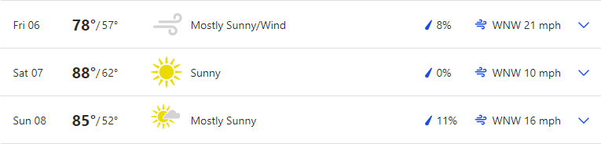

Reservoir Levels & Boat ramps:
American Falls: 15% full, elevation 4318 only Westside boat ramp is open but barely
Lake Walcott: 97% full, elevation 4245 boat ramp is open
Little Wood: 2% full, elevation 5147, Little Wood boat ramp is closed

Stocking:
Lake Cleveland (SE of Twin) 5000,

Fishing Tournaments:
None

Tightlines 208 Tip of the week with Jordan Rodriguez

Treasure Valley

Weather: Mountain Home Sunset: 8:58
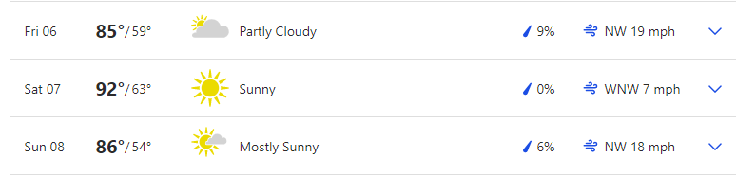

Boise Sunset 9:02
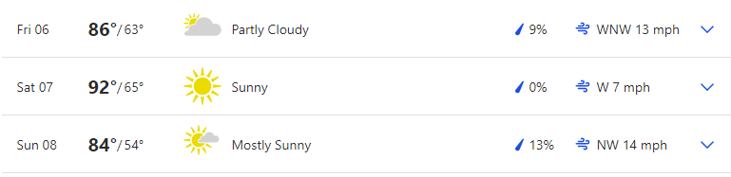

Reservoir Levels & Boat ramps:
Anderson Ranch: 45% full, Elevation 4137, All boat ramps open except Deer creek (4159) and Pine (4151)
Arrow Rock: 17% Full, Elevation 3108, High ramp is closed but the low ramp is open
Lucky Peak: 75% full, Elevation 3029, All ramps are open except Robie creek, Macks creek, and Barclay Bay
Lake Lowell: 55% full, Elevation 2522, All ramps are open

Stocking:
Featherville Dredge pond, 1000
N. Fork Boise river, S fork Payette river, 1750

Fishing Tournaments:
July 31 Kayak Fishing NW Black Canyon Reservoir Black Canyon Park/Emmett City Park

Fish and Game interview, Martin Koenig

Make sure you visit us at Southern Idaho Fishing dot com for links to all the information we provide here. You can also contact us through the site.

Cascade Area

Weather: Sunset 9:03

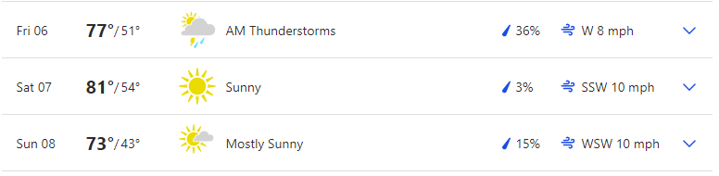 Reservoir Levels & Boat ramps:
Cascade: 69% full, Elevation 4820, All ramps except French creek (4824) and Buttercup are open. SISCRA is at its limit.
Deadwood: 56% full, Elevation 5309, Cozy Cove ramp is open
NEW: Mann Creek: 36% full, Elevation 2858, Both South and North ramps are open

Stocking:
None

Fishing Tournaments:

None

Want to be a part of the show? Email us with questions or your fishing report from your last trip. Email:

General emails: southernidahofr@gmail.com

Fish emails: myfish@southernidahofishing.com

Viewer questions: questions@southernidahofishing.com

Kyle Sandy Deadwood Outfitters

Snake River Reservoirs

Weather: SUNSET 8:08
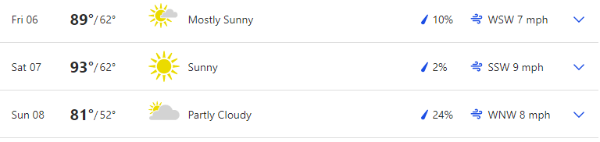

Stocking: No reports

Fishing Tournaments: None

You can find us on Facebook groups or you can follow us on Twitter @idaho_report

Moon Phases:
New moon Aug 8, First Quarter Aug 15
Perigee August 17, Apogee August 29
The moon's orbit around the earth is not round, but elliptical. At the most distant point (apogee), it's about 252,000 miles away. At its closest position (perigee), the moon is about 233,000 miles distant. Some theorists feel that the moon's greater gravitational pull (as much as 20 percent stronger during perigee positions) means solunar peaks at this time create even better fishing potential. When the moon's closest, it's also sometimes called a "super moon," due to its additional influence on tides.
So, two weekends ago was an A+ and last weekend was not forecasted to be great although I did some folks had success. This weekend is going to be one of those decent weekends to get out. Your peak times this weekend will be between 1 to 3 am overnight and 1 to 3 pm in the afternoon and the evening peak times are 8 to 9 pm.

Grade: B+ to A (depending on the day)

