Magic Valley

Weather: Sunset 8:21

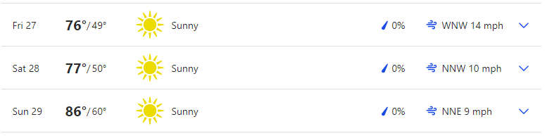

Reservoir Levels & Boat ramps:
American Falls: 15% full, elevation 4318 only Westside boat ramp is open but barely
Lake Walcott: 97% full, elevation 4245 boat ramp is open
Little Wood: 1% full, elevation 5137, Little Wood boat ramp is closed
NEW Ririe: 61% full, elevation 5089 Blacktail and Juniper boat ramps are open

Stocking:
No major stocking to report

Fishing Tournaments:
AUG 28 Idaho Walleye Unlimited Lake Walcott/Salmon Falls Creek Reservoir Walcott Park/Lud Drexler

Tightlines 208 Tip of the week with Jordan Rodriguez

Treasure Valley

Weather: Mountain Home Sunset: 8:26
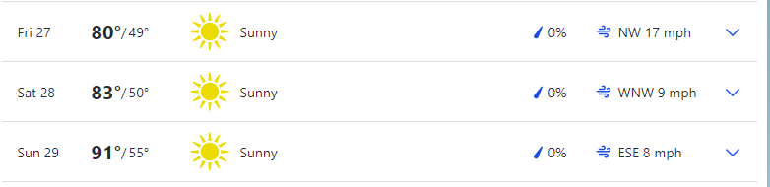

Boise Sunset 8:29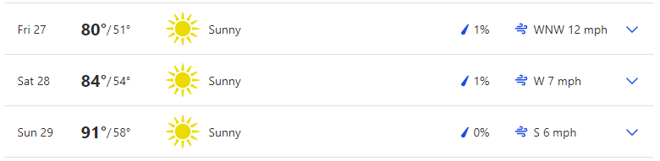

Reservoir Levels & Boat ramps:
Anderson Ranch: 42% full, Elevation 4130, All boat ramps open except Deer creek (4159), Pine (4151) and Fall Creek.
Arrow Rock: 25% Full, Elevation 3125, both High ramp and low ramp is open
Lucky Peak: 32% full, Elevation 2974, All ramps are closed except for 2. Your only way into LP is Turner Gulch and Spring Shores main ramp.
Lake Lowell: 49% full, Elevation 2521, All ramps are open

Stocking:
Lowman ponds 600
Boise river over 2000 in various locations

Fishing Tournaments:

AUG 28 Intermountain Bass Anglers CJ Strike Black Sands

Make sure you visit us at Southern Idaho Fishing dot com for links to all the information we provide here. You can also contact us through the site.

Cascade Area

Weather: Sunset 8:30

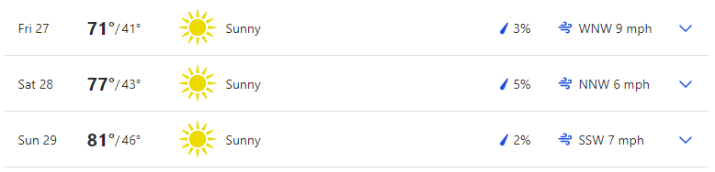 Reservoir Levels & Boat ramps:
Cascade: 59% full, Elevation 4817, All ramps except French creek, Buttercup, Boulder Creek, and SISCRA are open.
Deadwood: 41% full, Elevation 5298, Cozy Cove ramp is open barely
Mann Creek: 18% full, Elevation 2844, the South ramp is closed but the North ramp is open

Stocking:
Various locations along Payette, 1000

Fishing Tournaments:

None

Want to be a part of the show? Email us with questions or your fishing report from your last trip. Email:

General emails: southernidahofr@gmail.com

Fish emails: myfish@southernidahofishing.com

Viewer questions: questions@southernidahofishing.com

Kyle Sandy Deadwood Outfitters

Snake River Reservoirs

Weather: SUNSET 7:34 PST
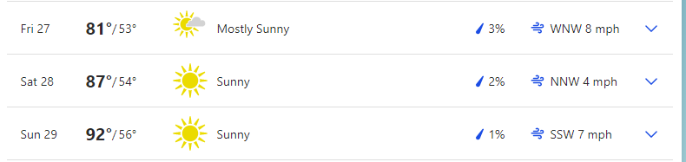

Reservoir Levels & Boat ramps:
Brownlee: 27 feet from full, Elevation 2077, All ramps are open except Spring recreation and Steck Park.

Stocking: No reports

Fishing Tournaments:

AUG 28 Idaho Bassmasters Brownlee Reservoir Woodhead

You can find us on Facebook groups or you can follow us on Twitter @idaho_report

Moon Phases:
Last quarter Aug 30, new moon Sep 6
Apogee August 29, Perigee Sept 11
The moon's orbit around the earth is not round, but elliptical. At the most distant point (apogee), it's about 252,000 miles away. At its closest position (perigee), the moon is about 233,000 miles distant. Some theorists feel that the moon's greater gravitational pull (as much as 20 percent stronger during perigee positions) means solunar peaks at this time create even better fishing potential. When the moon's closest, it's also sometimes called a "super moon," due to its additional influence on tides.
We are heading into the last quarter and fishing will be mediocre at best. If going out, your best times are 12 and 2 over night and again in the afternoon. Evening peak times are between 6 and 8. Fishing looks to be best on Sunday.

Grade: C to a B (depending on the day) Fishing is pretty weak Friday and Saturday with solunar patterns and wind speeds. If you are picking one day I would go out on Sunday. Friday and Saturday get a C with Sunday being the best day with a B grade.

