Magic Valley

Weather: Sunset 8:31

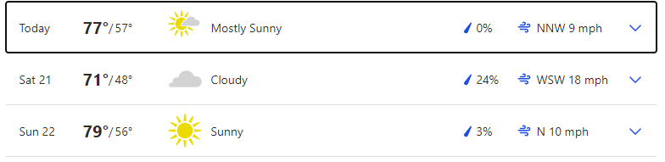

Reservoir Levels & Boat ramps:
American Falls: 13% full, elevation 4317 only Westside boat ramp is open but barely
Lake Walcott: 97% full, elevation 4245 boat ramp is open
Little Wood: 2% full, elevation 5141, Little Wood boat ramp is closed
NEW Ririe: 63% full, elevation 5091 Blacktail and Juniper boat ramps are open

Stocking:
No major stocking to report

Fishing Tournaments:

AUG 21 Mini-Cassia Bassers Milner Lake Golf Course

Tightlines 208 Tip of the week with Jordan Rodriguez

Treasure Valley

Weather: Mountain Home Sunset: 8:36
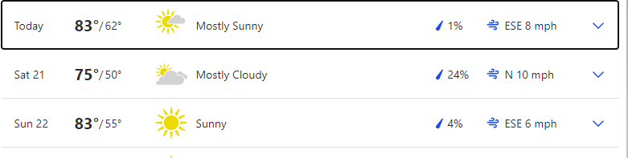

Boise Sunset 8:39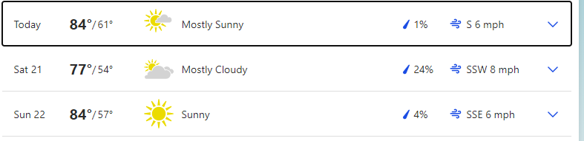

Reservoir Levels & Boat ramps:
Anderson Ranch: 42% full, Elevation 4132, All boat ramps open except Deer creek (4159), Pine (4151) and Fall Creek.
Arrow Rock: 23% Full, Elevation 3121, both High ramp and low ramp is open
Lucky Peak: 45% full, Elevation 2992, All ramps are closed except for 2. Your only way into LP is Turner Gulch and Spring Shores main ramp.
Lake Lowell: 50% full, Elevation 2521, All ramps are open

Stocking:
Big Trinity lake 1000
N. Fork Boise and S. Fork Payette 1750 ea

Fishing Tournaments:

AUG 21 American Bass Association CJ Strike Black Sands

Make sure you visit us at Southern Idaho Fishing dot com for links to all the information we provide here. You can also contact us through the site.

Cascade Area

Weather: Sunset 8:40

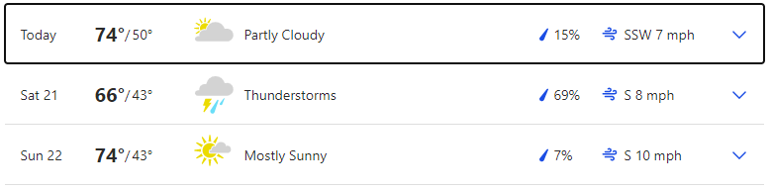 Reservoir Levels & Boat ramps:
Cascade: 62% full, Elevation 4817, All ramps except French creek, Buttercup, and SISCRA are open.
Deadwood: 45% full, Elevation 5301, Cozy Cove ramp is open
NEW: Mann Creek: 24% full, Elevation 2849, the South ramp is closed but the North ramp is open

Stocking:
None

Fishing Tournaments:

None

Want to be a part of the show? Email us with questions or your fishing report from your last trip. Email:

General emails: southernidahofr@gmail.com

Fish emails: myfish@southernidahofishing.com

Viewer questions: questions@southernidahofishing.com

Kyle Sandy Deadwood Outfitters

Snake River Reservoirs

Weather: SUNSET 7:44 PST
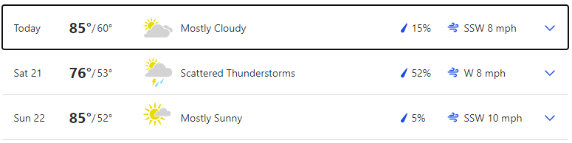

Reservoir Levels & Boat ramps:
Brownlee: 26 feet from full, Elevation 2052, All ramps are open except Spring recreation and Steck Park.

Stocking: No reports

Fishing Tournaments:

AUG 14 Treasure Valley Bass Brownlee Reservoir Woodhead

You can find us on Facebook groups or you can follow us on Twitter @idaho_report

Moon Phases:
Full Moon August 22, last quarter Aug 30
Apogee August 29, Perigee Sept 11
The moon's orbit around the earth is not round, but elliptical. At the most distant point (apogee), it's about 252,000 miles away. At its closest position (perigee), the moon is about 233,000 miles distant. Some theorists feel that the moon's greater gravitational pull (as much as 20 percent stronger during perigee positions) means solunar peaks at this time create even better fishing potential. When the moon's closest, it's also sometimes called a "super moon," due to its additional influence on tides.
Another great weekend to be out on the water to be out on the water (or next to it) and catching fish. The full moon is Sunday, so really the next 6 days should be really great for fishing. Your peak times over the weekend are; Between 1 and 3 am and the same cycle in the afternoon and then again at 8 pm as the sun is going down for the day.

Grade: B+ to A+ (depending on the day) The low pressure system rolling through Saturday is the only thing keeping the entire weekend from being an A+

