Magic Valley

Weather: Sunset 8:43

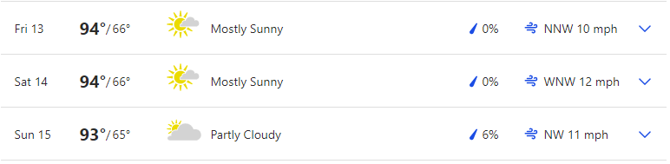

Reservoir Levels & Boat ramps:
American Falls: 15% full, elevation 4318 only Westside boat ramp is open but barely
Lake Walcott: 99% full, elevation 4245 boat ramp is open
Little Wood: 1% full, elevation 5134, Little Wood boat ramp is closed
NEW Ririe: 66% full, elevation 5093 Blacktail and Juniper boat ramps are open

Stocking:
No major stocking to report, some small streams

Fishing Tournaments:
AUG 14 Magic Valley Bassmasters Lake Walcott Lake Walcott State Park

Tightlines 208 Tip of the week with Jordan Rodriguez

Treasure Valley

Weather: Mountain Home Sunset: 8:49
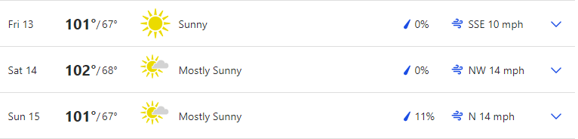

Boise Sunset 8:52
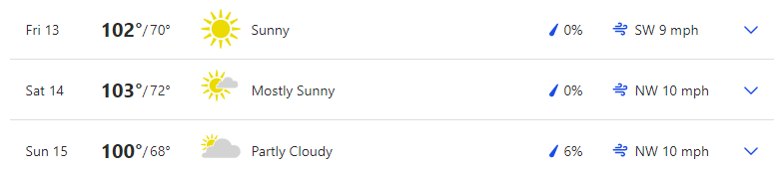

Reservoir Levels & Boat ramps:
Anderson Ranch: 44% full, Elevation 4135, All boat ramps open except Deer creek (4159) and Pine (4151). Fall Creek is barely accessible.
Arrow Rock: 20% Full, Elevation 3115, High ramp is closed but the low ramp is open
Lucky Peak: 62% full, Elevation 3015, All ramps are open except Robie creek, Macks creek, Barclay Bay, and Spring Shores #2. Your only way into LP is Turner Gulch and Spring Shores main ramp.
Lake Lowell: 54% full, Elevation 2522, All ramps are open

Stocking:
Various locations along the Boise river: 3000

Fishing Tournaments:

AUG 15 Mountain Home Hawg Hunters CJ Strike Black Sands

Make sure you visit us at Southern Idaho Fishing dot com for links to all the information we provide here. You can also contact us through the site.

Cascade Area

Weather: Sunset 8:53

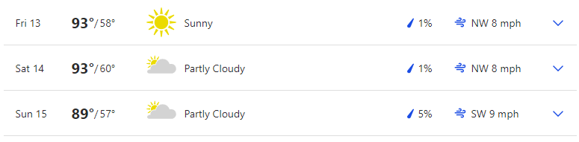 Reservoir Levels & Boat ramps:
Cascade: 66% full, Elevation 4819, All ramps except French creek (4824) and Buttercup are open. SISCRA is at its limit.
Deadwood: 51% full, Elevation 5306, Cozy Cove ramp is open
NEW: Mann Creek: 32% full, Elevation 2856, Both South and North ramps are open

Stocking:
Browns pond; 1000
Upper Payette Lake; 2000
Rowlands Pond; 1000

Fishing Tournaments:

None

Want to be a part of the show? Email us with questions or your fishing report from your last trip. Email:

General emails: southernidahofr@gmail.com

Fish emails: myfish@southernidahofishing.com

Viewer questions: questions@southernidahofishing.com

Kyle Sandy Deadwood Outfitters

Snake River Reservoirs

Weather: SUNSET 7:57 PST
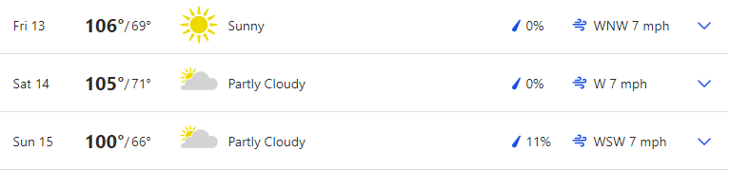

Reservoir Levels & Boat ramps:
Brownlee: 21 feet from full, Elevation 2057, All ramps are open.

Stocking: No reports

Fishing Tournaments:

AUG 14 Treasure Valley Bass Brownlee Reservoir Woodhead

You can find us on Facebook groups or you can follow us on Twitter @idaho_report

Moon Phases:
First Quarter Aug 15, Full Moon August 22
Perigee August 17, Apogee August 29
The moon's orbit around the earth is not round, but elliptical. At the most distant point (apogee), it's about 252,000 miles away. At its closest position (perigee), the moon is about 233,000 miles distant. Some theorists feel that the moon's greater gravitational pull (as much as 20 percent stronger during perigee positions) means solunar peaks at this time create even better fishing potential. When the moon's closest, it's also sometimes called a "super moon," due to its additional influence on tides.
Last weekend was a pretty good weekend to be out if you hit those peak times. I ran into a couple of fishermen coming off the water at CJ just as peak times were coming in this past weekend. They said they didn’t catch anything and I tried to tell them they were leaving just as the bite was about to be on. He said he didn’t believe in solunar times but wished me luck. It worked cause we caught a mess o fish. This weekend is going to be another decent weekends to get out, especially early in the mornings. Your peak times this weekend will be between 6 to 7 am in the morning, Noon and 2 in the afternoon and the evening peak times are 6 to 9 pm. If you are picking one day over the other, I highly recommend early Friday morning for your best fishing.

Grade: B+ to A (depending on the day)

