Magic Valley

Weather: Sunset 8:59

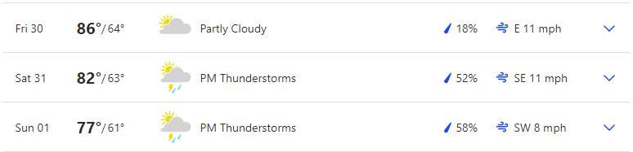

Reservoir Levels & Boat ramps:
American Falls: 15% full, elevation 4318 only Westside boat ramp is open but barely
Lake Walcott: 88% full, elevation 4244 boat ramp is open
Little Wood: 5% full, elevation 5151, Little Wood boat ramp is closed

Stocking:
No major stocking in the Magic Valley

Fishing Tournaments:
July 31 Idaho Basshunters Anderson Ranch Reservoir Curlew/Curlew

Tightlines 208 Tip of the week with Jordan Rodriguez

Treasure Valley

Weather: Mountain Home Sunset: 9:07
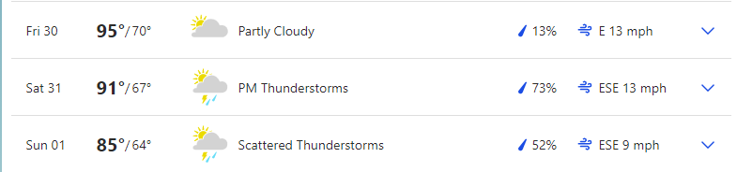

Boise Sunset 9:10
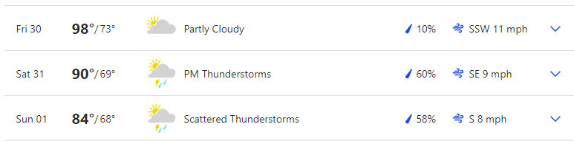

Reservoir Levels & Boat ramps:
Anderson Ranch: 47% full, Elevation 4139, All boat ramps open except Deer creek (4159) and Pine (4151)
Arrow Rock: 14% Full, Elevation 3100, High ramp is closed but the low ramp is open
Lucky Peak: 97% full, Elevation 3047, All ramps are open.
Lake Lowell: 56% full, Elevation 2523, All ramps are open

Stocking:
No major stocking other than Rowland Pond 1000 (just east of Little Payette lake)

Fishing Tournaments:
July 31 Idaho Basshunters Anderson Ranch Reservoir Curlew/Curlew
July 31 Payette River Bassmasters Lake Lowell Caldwell Ramp

Make sure you visit us at Southern Idaho Fishing dot com for links to all the information we provide here. You can also contact us through the site.

Cascade Area

Weather: Sunset 9:12

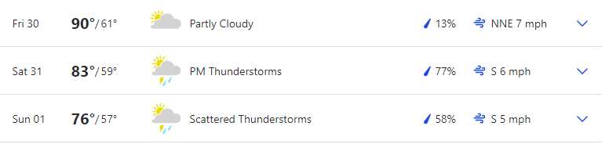 Reservoir Levels & Boat ramps:
Cascade: 73% full, Elevation 4821, All ramps except French creek (4824) are open and Buttercreek is at its limit.
Deadwood: 61% full, Elevation 5313, Cozy Cove ramp is open
NEW: Mann Creek: 43% full, Elevation 2862, Both South and North ramps are open

Stocking:
None

Fishing Tournaments:

JUL 31 Intermountain Bass Anglers Lake Cascade Boulder Creek/Boulder Creek

Want to be a part of the show? Email us with questions or your fishing report from your last trip. Email:

General emails: southernidahofr@gmail.com

Fish emails: myfish@southernidahofishing.com

Viewer questions: questions@southernidahofishing.com

Kyle Sandy Deadwood Outfitters

Snake River Reservoirs

Weather: SUNSET 8:17
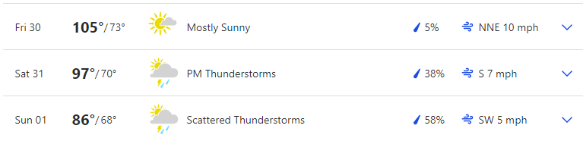

Stocking: No reports

Fishing Tournaments: None

You can find us on Facebook groups or you can follow us on Twitter @idaho_report

Moon Phases:
Last (3rd) quarter July 31, New moon Aug 8
Apogee August 2, Perigee August 17
The moon's orbit around the earth is not round, but elliptical. At the most distant point (apogee), it's about 252,000 miles away. At its closest position (perigee), the moon is about 233,000 miles distant. Some theorists feel that the moon's greater gravitational pull (as much as 20 percent stronger during perigee positions) means solunar peaks at this time create even better fishing potential. When the moon's closest, it's also sometimes called a "super moon," due to its additional influence on tides.
I said last weekend was the weekend to get out and go fishing and it was. As good as last weekend was, this weekend is going to be the polar opposite. This is going to be a great weekend to stay home and get those odd jobs done around the house my friends. We are coming out of the full moon phase and fishing looks to be pretty poor all weekend. If you just have to get out and do some fishing, your peak times this weekend will be between 7 to 9 am overnight and 8 to 10 pm in the evening but those are barely in the good category.

